.



03-SelectionStructuresinPython

**Department of Computer ScienceandEngineering**|**Rajalakshmi EngineeringCollege**

38

**Ex. No. : 3.1 Date: 12.04.24 Register No.: 230701368 Name : AL UMA**



# ClassifyingTriangles

Atrianglecanbeclassifiedbasedonthelengthsofitssidesasequilateral,isosceles or scalene.Allthreesidesofanequilateraltrianglehavethesamelength.An isosceles triangle has two sides that are the same length, and a third side that is a different length. If all of the sides have different lengths then the triangle is scalene.

Write a program that reads the lengths of the three sides of a triangle from theuser. Then display a message that states the triangle’s type.

SampleInput1

60

60

60

SampleOutput1

That'saequilateraltriangle Sample Input 2

40

40

80

SampleOutput2

That's a isosceles triangle Sample Input 3

50

60

70

SampleOutput3

That'sascalene triangle

.

**Department of Computer ScienceandEngineering**|**Rajalakshmi EngineeringCollege**

39

**For example:**

.



|  |  |
| --- | --- |
| **Input** | **Result** |
| 60 | That's a equilateral triangle |
| 60 |  |
| 60 |  |
|  |  |
| 40 | That's a isoscele striangle |
| 40 |  |
| 80 |  |

**Program:**

a=int(input()) b=int(input()) c=int(input())

if(a==b and b==c and c==a): print("That's","a","equilateral triangle")

elif(a!=b and a!=c and b!=c): print("That's","a","scalene triangle")

else:

print("That's","a","isosceles triangle")

**Department of Computer ScienceandEngineering**|**Rajalakshmi EngineeringCollege**

40

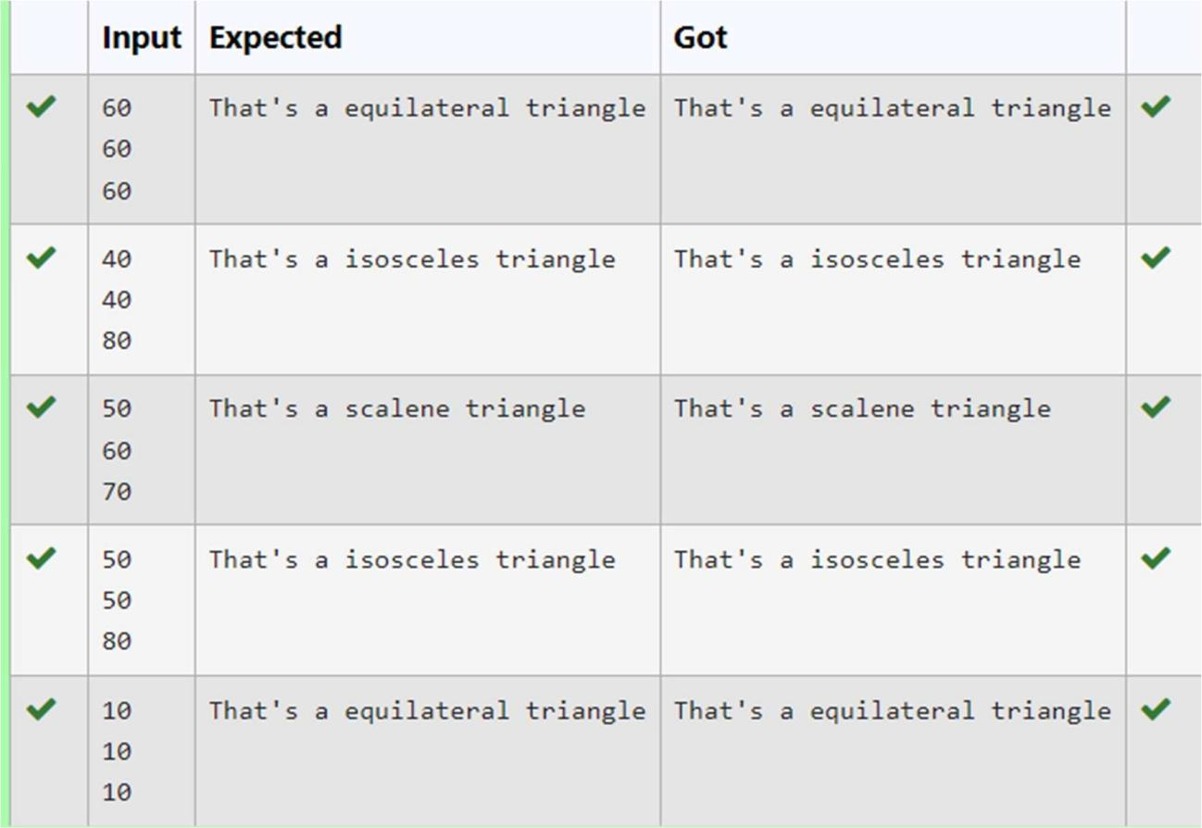

.



**Department of Computer ScienceandEngineering**|**Rajalakshmi EngineeringCollege**

41

**Ex.No. : 3.2 Date:12.04.24**

.



**RegisterNo.:230701368 Name: AL UMA**

# VowelorConsonant

Inthisexerciseyouwillcreateaprogramthatreadsaletterofthealphabetfrom the user.If theuserentersa,e,i,ooruthenyourprogramshoulddisplaya messageindicating that the entered letter is a vowel. If the user enters'y' then your programshoulddisplayamessageindicatingthatsometimesyisavowel,andsometimes yisa consonant.Otherwiseyourprogram shoulddisplaya messageindicatingthat the letter is a consonant.

SampleInput1 i

SampleOutput1 It's a vowel.

SampleInput2 y

SampleOutput2

Sometimesit'savowel...Sometimesit'saconsonant.

SampleInput3 c

SampleOutput3 It's a consonant.

**Forexample:**



|  |  |
| --- | --- |
| **Input** | **Result** |
| y | Sometimesit'savowel...Sometimesit'saconsonant. |
| u | It'savowel. |
| p | It'saconsonant. |

**Department of Computer ScienceandEngineering**|**Rajalakshmi EngineeringCollege**

42

.



**Program:**

x=input() if(x=='y'):

print("Sometimesit'savowel...Sometimesit'saconsonant.")

elif(x=='a' or x=='e' or x=='i' or x=='o' or x=='u'):

print("It'savowel.") else:

print("It'saconsonant.")

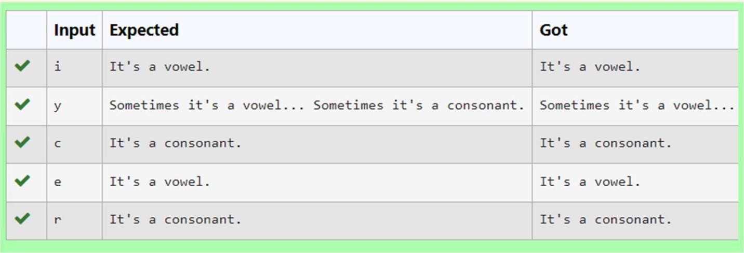

**Department of Computer ScienceandEngineering**|**Rajalakshmi EngineeringCollege**

43

**Ex. No. : 3.3 Date: 12.04.24 Register No.: 230701368 Name: AL UMA**



# ElectricityBill

Write a program to calculate and print the Electricity bill wheretheunit consumed by theuserisgivenfromtestcase.Itprintsthetotalamountthecustomerhastopay.The charge are as follows:

Unit Charge/Unit

Upto199 @1.20

200 and above but less than 400@1.50 400 and above but less than 600@1.80 600 and above @2.00

If bill exceeds Rs.400 then a surcharge of 15% will be charged and the minimum billshould be of Rs.100/-

SampleTestCases Test Case 1

Input 50

Output 100.00

TestCase2 Input

300

Output 517.50

**Forexample:**

.

**Department of Computer ScienceandEngineering**|**Rajalakshmi EngineeringCollege**

44



|  |  |
| --- | --- |
| **Input** | **Result** |
|  | |
| 100.00 | 120.00 |

**Program:** a=float(input()) if(a<200):



b=a*1.20 if(b<=100):

b=100

print(format(b,".2f")) else:

print(format(b,".2f")) elif(a>=200 and a<400):

c=a*1.50 if(c>=400):

print(format(c*0.15+c,".2f")) else:

print(format(c,".2f")) elif(a>=400 and a<600):

d=a*1.80 print(format(d*0.15+d,".2f"))

elif(a>600):A

.

**Department of Computer ScienceandEngineering**|**Rajalakshmi EngineeringCollege**

45

e=a*2.00 print(format(e*0.15+e,".2f"))

.



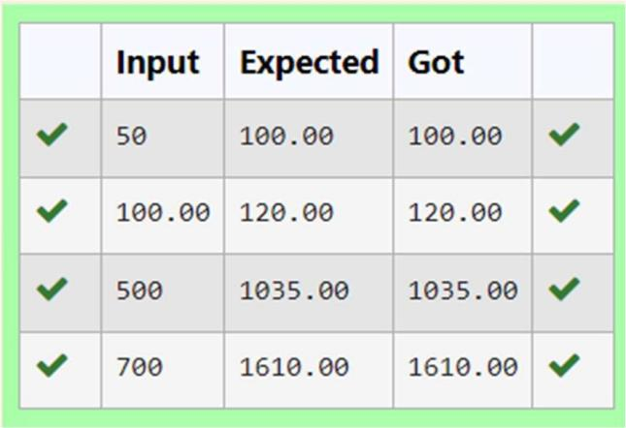

**Department of Computer ScienceandEngineering**|**Rajalakshmi EngineeringCollege**

46



**Ex.No. : 3.4 Date:12.04.24**

**RegisterNo.:230701368 Name:AL UMA**

# IN/OUT

Ms. Sita, the faculty handling programming lab for you is very strict. Your seniors havetold you that she will not allow you to enter the week's lab if you have not completed atleast half the number of problems given last week. Many of you didn't understand this statement and so they requested the good programmers from your batch to write a program to find whether a student will be allowed into a week's lab given the number of problems givenlastweekandthe numberofproblemssolvedbythestudentinthat week.

InputFormat:

Inputconsistsof2integers.

The first integer corresponds to the number of problems given and the second integer corresponds to the number of problems solved.

OutputFormat:

Output consists of the string “IN” or“OUT”. Sample Input and Output:

Input 8

3

Output OUT

**Forexample:**

.

**Department of Computer ScienceandEngineering**|**Rajalakshmi EngineeringCollege**

47

.



|  |  |
| --- | --- |
| **Input** | **Result** |
|  | |
| 8  3 | OUT |

**Program:** a=int(input()) b=int(input()) c=a//2 if(b>=c):

print("IN") else:

print("OUT")

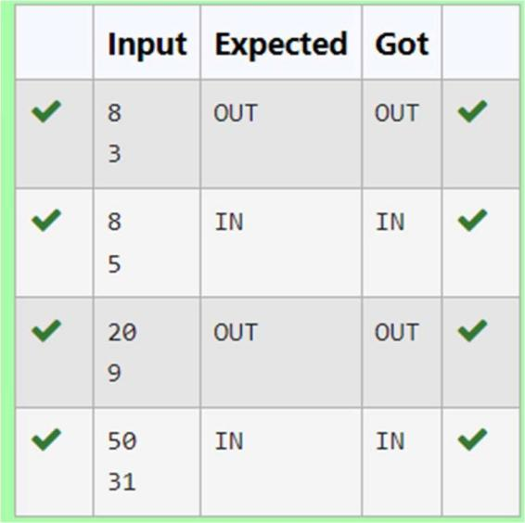

**Department of Computer ScienceandEngineering**|**Rajalakshmi EngineeringCollege**

48



**Ex.No. : 3.5 Date:12.04.24**

**RegisterNo.:230701368 Name:AL UMA**

# Secondlastdigit

Writeaprogramthatreturnsthesecondlastdigitofthegivennumber.Secondlastdigit is being referred 10the digit in the tens place in the given number.

Forexample,ifthegivennumberis197,thesecondlastdigitis9.

Note1 - The second last digit should be returned as a positive number. i.e. if the given number is -197, the second last digit is 9.

Note2 - If the given number is a single digit number, then the second last digit does not exist. In such cases, the program should return -1. i.e. if the given number is 5, the second last digit should be returned as -1.

**Forexample:**



|  |  |
| --- | --- |
| **Input** | **Result** |
|  | |
| 197 | 9 |

**Program:** a=int(input()) b=abs(a)

.

**Department of Computer ScienceandEngineering**|**Rajalakshmi EngineeringCollege**

49

if(b>=10): c=b//10 d=c%10 print(d) else:

.



print(-1)

**Department of Computer ScienceandEngineering**|**Rajalakshmi EngineeringCollege**

50

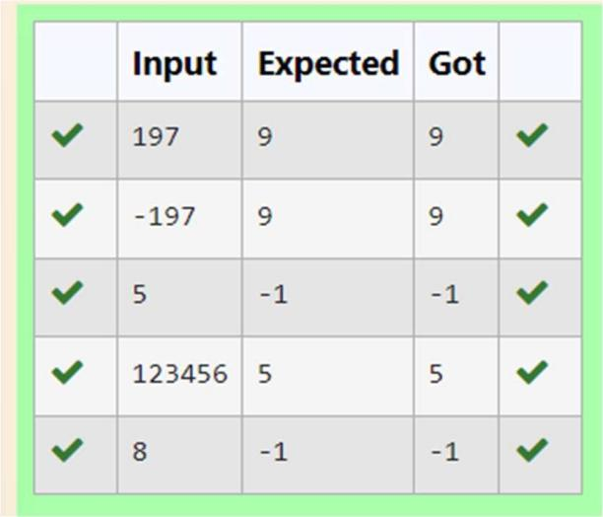

.



**Department of Computer ScienceandEngineering**|**Rajalakshmi EngineeringCollege**

51

**Ex.No. : 3.6 Date:12.04.24**



**RegisterNo.:230701368 Name: AL UMA**

# ChineseZodiac

The Chinese zodiac assigns animals to years in a 12 year cycle. One 12 year cycle isshown in the table below. The pattern repeats from there, with 2012 being another year of the dragon, and 1999 being another year of the hare.

Year Animal 2000Dragon

2001Snake

2002Horse

2003Sheep

2004Monkey

2005Rooster

2006Dog

2007Pig

2008Rat

2009Ox

2010Tiger

2011Hare

Write a program that reads a year from the user and displays the animal associated with that year. Your program should work correctly for any year greater than or equal to zero, not just the ones listed in the table.

SampleInput1

2010

SampleOutput1

2010istheyearoftheTiger. Sample Input 2

2020

SampleOutput2

.

**Department of Computer ScienceandEngineering**|**Rajalakshmi EngineeringCollege**

52

2020istheyearoftheRat.



**Program:** a=int(input()) b=a%12 if(b==0):

print(a,"istheyearoftheMonkey.") elif(b==1):

print(a,"istheyearoftheRooster.") elif(b==2):

print(a,"istheyearoftheDog.") elif(b==3):

print(a,"istheyearofthePig.") elif(b==4):

print(a,"istheyearoftheRat.") elif(b==5):

print(a,"istheyearoftheOx.") elif(b==6):

print(a,"istheyearoftheTiger.") elif(b==7):

print(a,"istheyearoftheHare.") elif(b==8):

print(a,"istheyearoftheDragon.") elif(b==9):

.

**Department of Computer ScienceandEngineering**|**Rajalakshmi EngineeringCollege**

53

print(a,"istheyaeroftheSnake.") elif(b==10):

.



print(a,"istheyearoftheHorse.") elif(b==11):

print(a,"istheyearoftheSheep.")

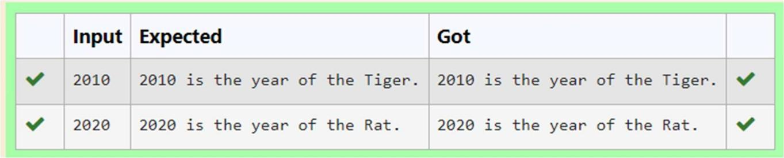

**Department of Computer ScienceandEngineering**|**Rajalakshmi EngineeringCollege**

54

**Ex.No. : 3.7 Date:12.04.24**



**RegisterNo.:230701368 Name:AL UMA**

# Pythagoreantriple

ThreenumbersformaPythagoreantripleifthesumofsquaresoftwonumbersisequal to the square of the third.

Forexample,3,5and4formaPythagoreantriple,since3*3+4*4=25=5*5 You are given three integers, a, b, and c. They need not be given in increasing order. If they form a Pythagorean triple, then print "Yes", otherwise, print "No".

SampleInput 3

5

4

SampleOutput yes

SampleTestCases Test Case 1

Input 3

5

4

Output yes

TestCase2 Input

5

8

2

Output no

.

**Department of Computer ScienceandEngineering**|**Rajalakshmi EngineeringCollege**

55

**Program:**

.



a=int(input()) b=int(input()) c=int(input())

if(a*a+b*b==c*corb*b+c*c==a*aorc*c+a*a==b*b): print("yes")

else:

print("no")

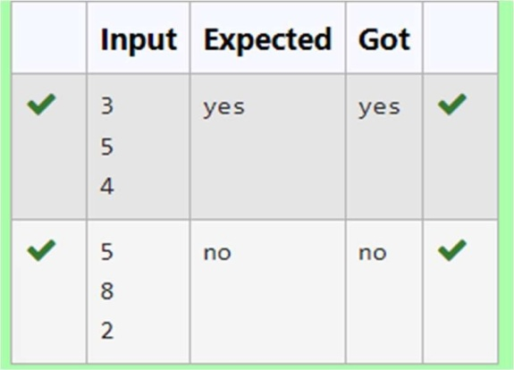

**Department of Computer ScienceandEngineering**|**Rajalakshmi EngineeringCollege**

56

**Ex.No. : 3.8 Date:12.04.24**



**RegisterNo.:230701368 Name: AL UMA**

# LeapYear

Most years have 365 days. However, the time required for the Earth to orbit the Sunis actually slightly more than that. As a result, an extra day, February 29, is included in some years to correct for this difference. Such years are referred to as leap years.The rules for determining whether or not a year is a leap year follow:

* Anyyearthatisdivisibleby 400isaleapyear.
* Oftheremainingyears,anyyearthatisdivisibleby100isnotaleapyear.
* Oftheremainingyears,any yearthatisdivisibleby4isa leapyear.
* Allotheryearsarenotleap years.

Writeaprogramthatreadsayearfromtheuseranddisplaysamessageindicating whether or not it is a leap year.

SampleInput1

1900

SampleOutput1

1900isnotaleapyear. Sample Input 2

2000

Sample Output 2 2000isaleapyear.

**Program:**

a=int(input()) b=a%100 c=a%400

if(b==0):

if(c==0):

print(a,"isaleapyear.") else:

.

**Department of Computer ScienceandEngineering**|**Rajalakshmi EngineeringCollege**

57

print(a,"isnotaleapyear.") elif(a%4==0):

.



print(a,"isaleapyear.")

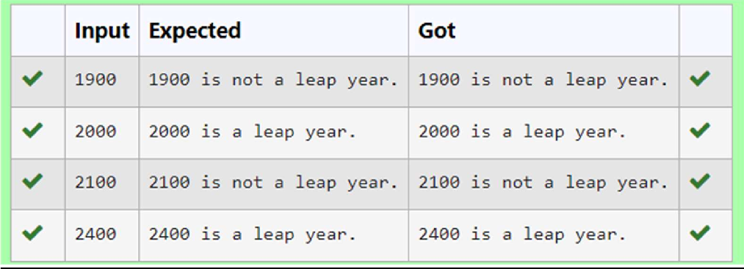

**Department of Computer ScienceandEngineering**|**Rajalakshmi EngineeringCollege**

58

**Ex. No. : 3.9 Date: 12.04.24 Register No.: 230701368 Name: AL UMA**

.



# Monthnametodays

The length of a month varies from 28 to 31 days. In this exercise you will createa programthat reads the name of a month from the user as a string. Then yourprogram should display the number of days in that month. Display “28 or 29 days”for February so that leap years are addressed.

Sample Input 1 FebruarySampleOutput1

Februaryhas28or29daysinit. Sample Input 2

March

Sample Output 2Marchhas31 days init. Sample Input 3

April

SampleOutput3April has 30 days in it. **For example:**



|  |  |
| --- | --- |
| **Input** | **Result** |
|  | |
| February | Februaryhas28or29daysinit. |

**Department of Computer ScienceandEngineering**|**Rajalakshmi EngineeringCollege**

59

**Program:** odd=['January','March','May','July','August','October','December'] even=['April','June','September','November']

.



a=input() if(a=='February'):

print("Februaryhas28or29daysinit.") if a in odd:

print(a,"has31daysinit.") if a in even:

print(a,"has30daysinit.")

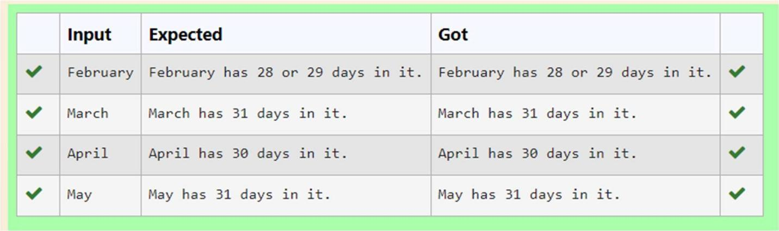

**Department of Computer ScienceandEngineering**|**Rajalakshmi EngineeringCollege**

60

**Ex. No. : 3.10 Date: 12.04.24 Register No.: 230701368 Name: AL UMA**



# AdmissionEligibility

Write a program to find the eligibility of admission for a professional course based onthe following criteria:

Marks in Maths >= 65 Marks in Physics >= 55 MarksinChemistry>=50 Or

Total in all three subjects >= 180 Sample Test Cases

TestCase1 Input

70

60

80

Output

Thecandidateiseligible Test Case 2

Input 50

80

80

Output

Thecandidateiseligible Test Case 3

Input 50

60

40

.

**Department of Computer ScienceandEngineering**|**Rajalakshmi EngineeringCollege**

61

Output

.



Thecandidateisnoteligible

**Forexample:**



|  |  |
| --- | --- |
| **Input** | **Result** |
|  | |
| 50 | Thecandidateiseligible |
| 80 |  |
| 80 |  |

**Program:** a=int(input()) b=int(input()) c=int(input())

if(a>=65 and b>=55 and c>=50): print("Thecandidateiseligible")

elif(a+b+c>=180):

print("Thecandidateiseligible") else:

print("Thecandidateisnoteligible")

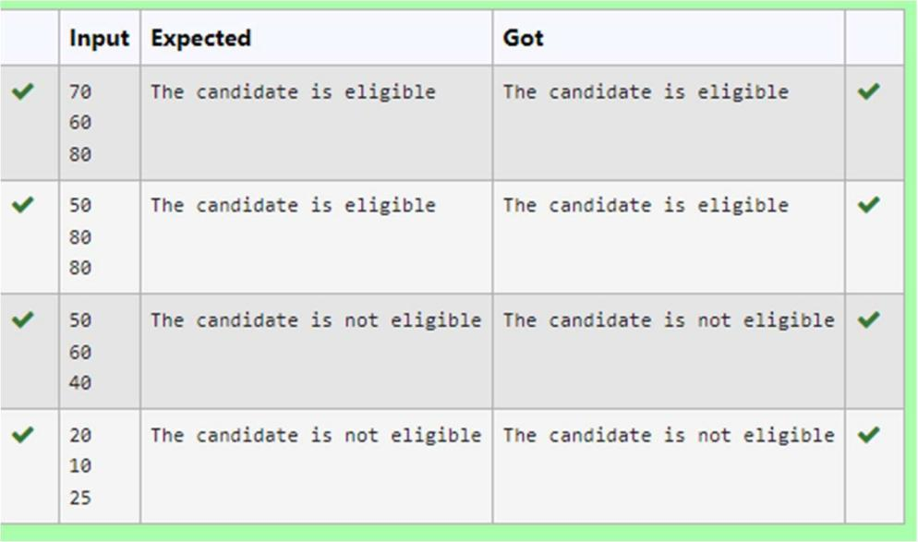

**Department of Computer ScienceandEngineering**|**Rajalakshmi EngineeringCollege**

62